**DBMS DAY 1 PRACTICAL LAB**

**(S.BARANI;192211152)**

**Q.no.1. Create an Emp table with the following fields:(EmpNo, EmpName, Job,Basic, DA, HRA,PF, GrossPay, NetPay) (Calculate DA as 30% of Basic and HRA as 40% of Basic) ( a ) Insert Five Records and calculate GrossPay and NetPay. ( b ) Display the employees whose Basic is lowest in each department . ( c ) If NetPay is less than <Rs. 10,000 add Rs. 1200 as special allowances . ( d ) Display the employees whose GrossPay lies between 10,000 & 20,000 ( e ) Display all the employees who earn maximum salary**

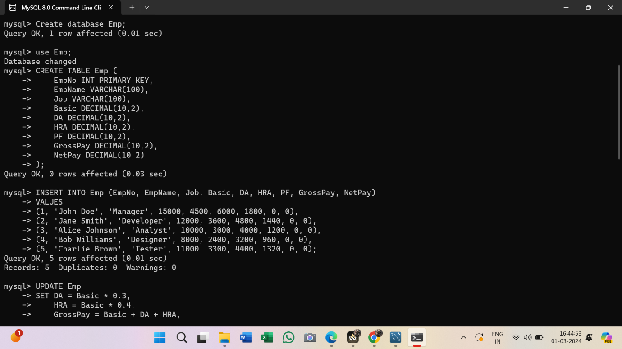

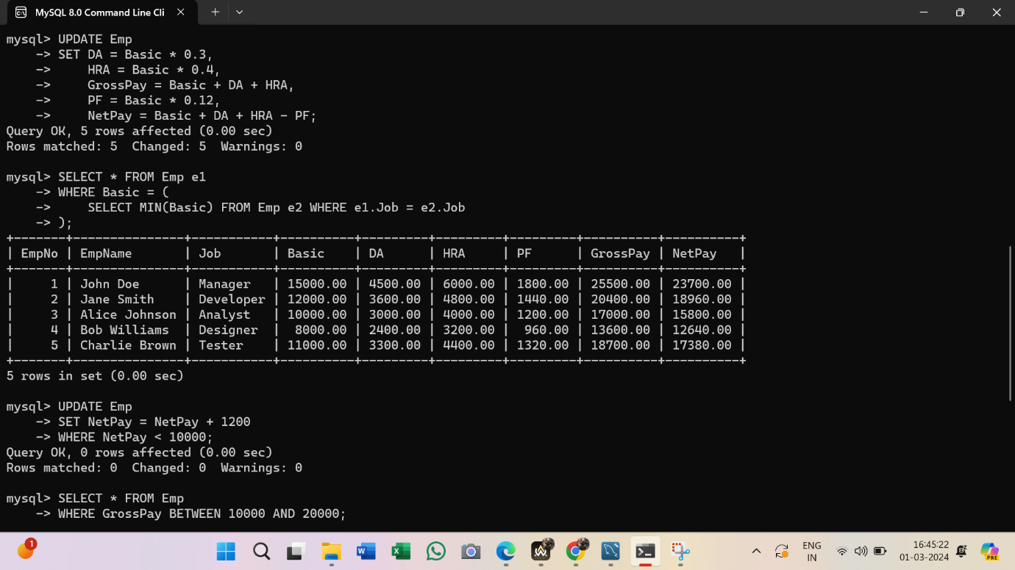

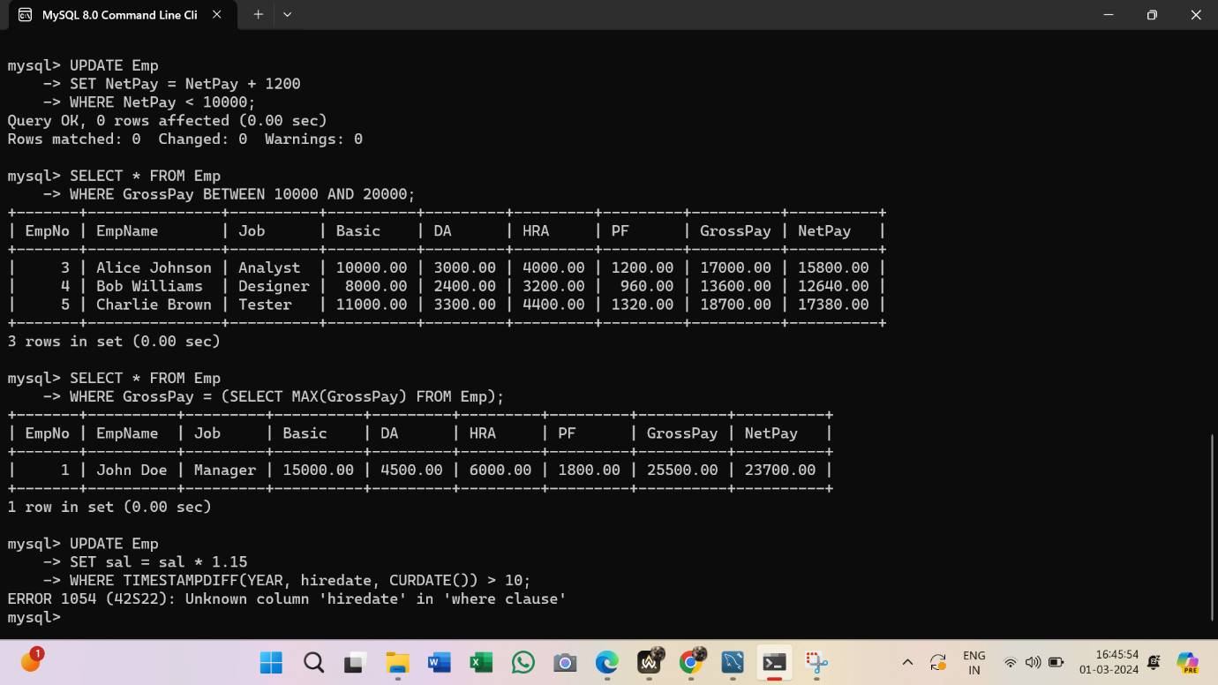

**Q.NO.2.An Enterprise wishes to maintain a database to automate its operations. Enterprise is divided into certain departments and each department consists of employees. The following two tables describes the automation schemas Dept (deptno, dname, loc) Emp (empno, ename, job, mgr, hiredate, sal, comm, deptno) a) Update the employee salary by 15%, whose experience is greater than 10 years. b) Delete the employees, who completed 30 years of service. c) Display the manager who is having maximum number of employees working under him?**

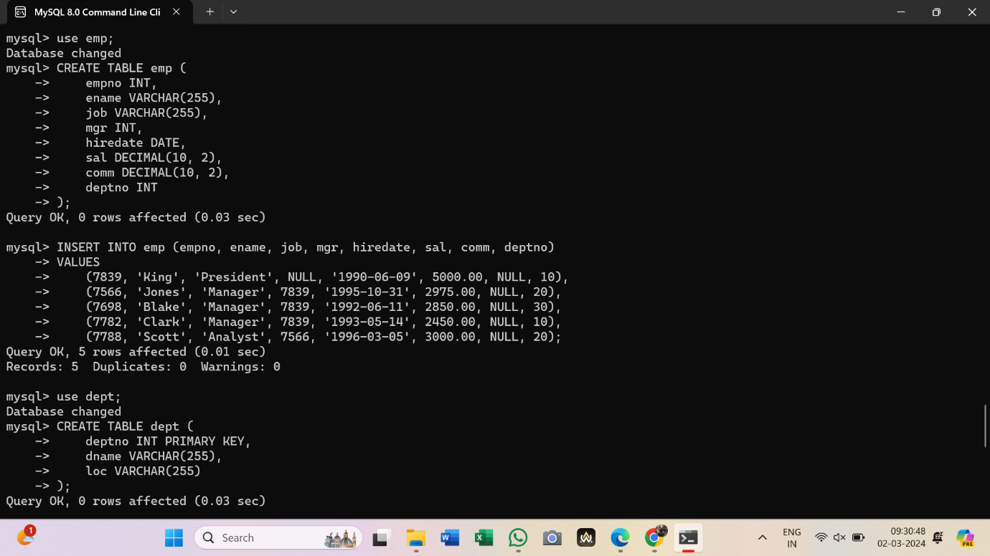

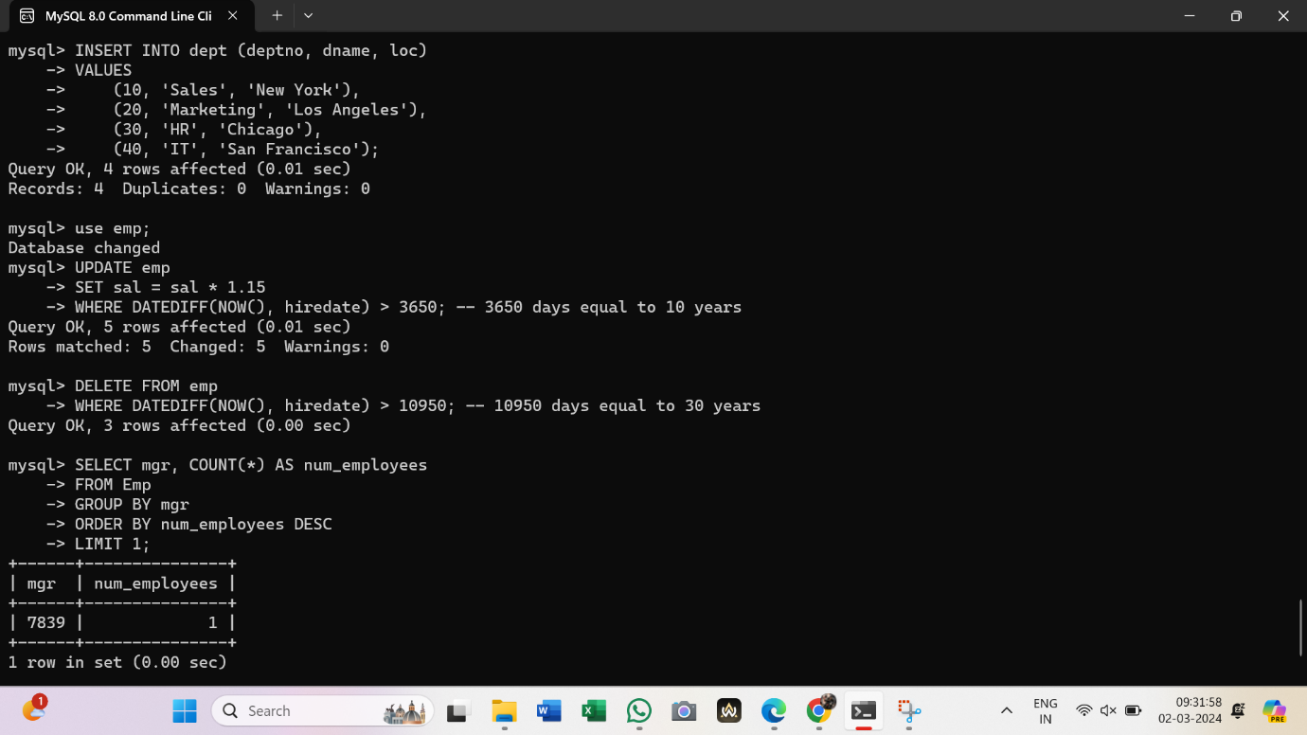

**Q.NO.3. Create a table STUDENT with under mentioned structure by using SQL Statement:**

|  |
| --- |
| **StdID Number Primary Key StdName Character (30) NOT NULL Sex Character(6) Male or Female Percentage Number SClass Number Sec Character Stream Character(10) Science or Commerce DOB Date Date of Birth** |

**b). Insert 6 records into STUDENT table. c). To display all the records form STUDENT table. d). To display only name and date of birth from the table STUDENT. e). To add a column (FIELD) in the STUDENT table, for example TeacherID as VARCHAR (20); f). To display student name, stream and percentage where percentage of student is more than 80 g). To delete the records form student table where StdId is 1016 h). To change a student name from SWATI to VERMA whose StdID is 1014 and also change percentage 86. i). To Drop (Delete) TeacherID field form a table.**

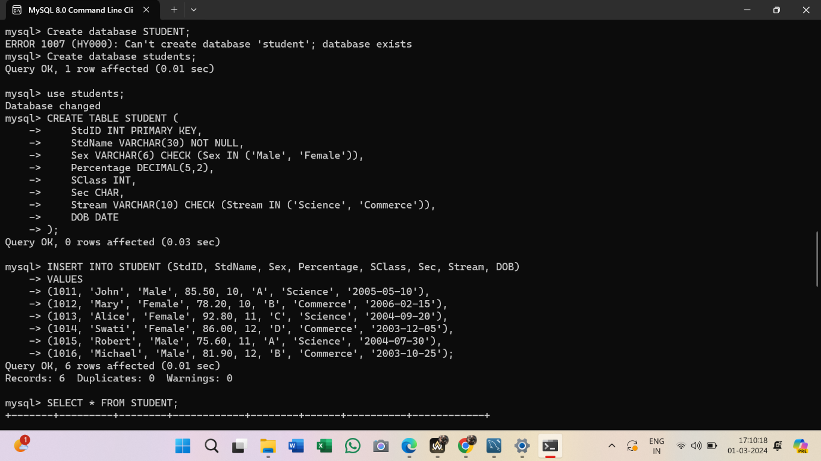

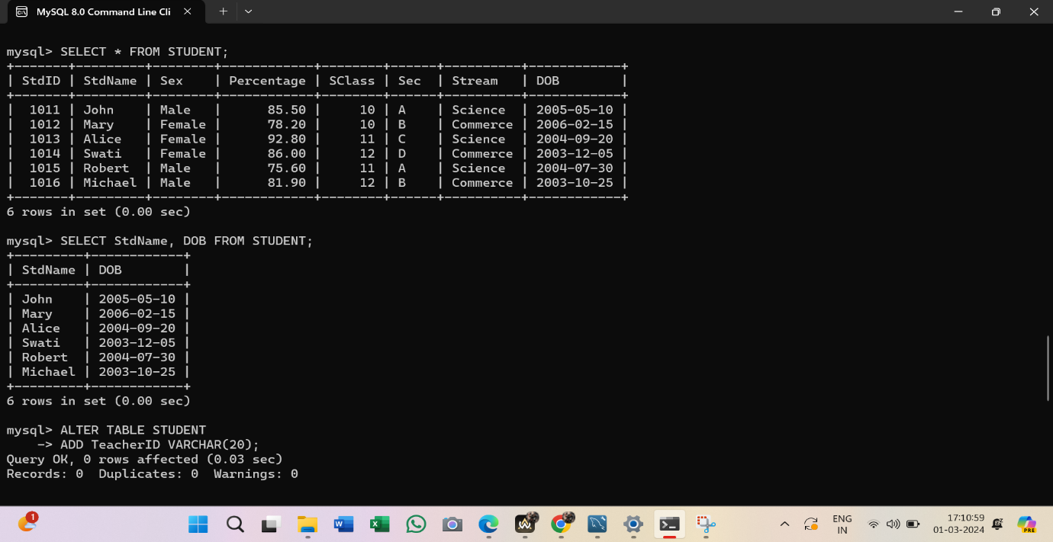

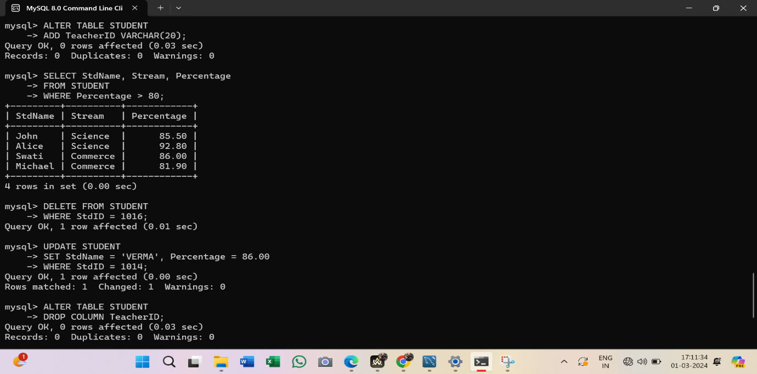

**Q.NO. 4). a). Creates a CUSTOMERS table with column name ID, NAME, AGE, ADDRESS and, SALARY and ID as a primary key. b).Insert a 5 new records into a table. c). Delete record customer name john from a table. d). Write the query to update customer salary whose age is greater than 50 in a table. e).Write the query to select the column name from a table f).Write the query to sort age in descending order g).Write the query to delete a table Customers from the database.**

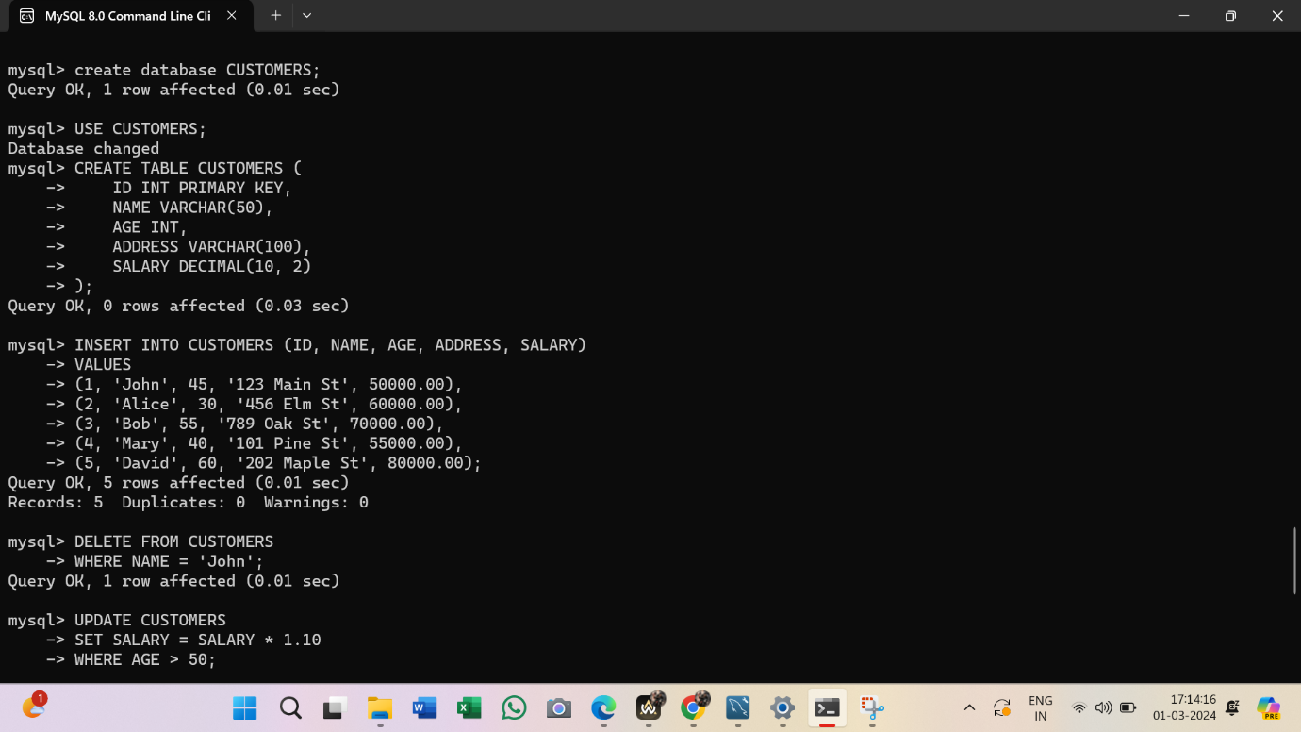

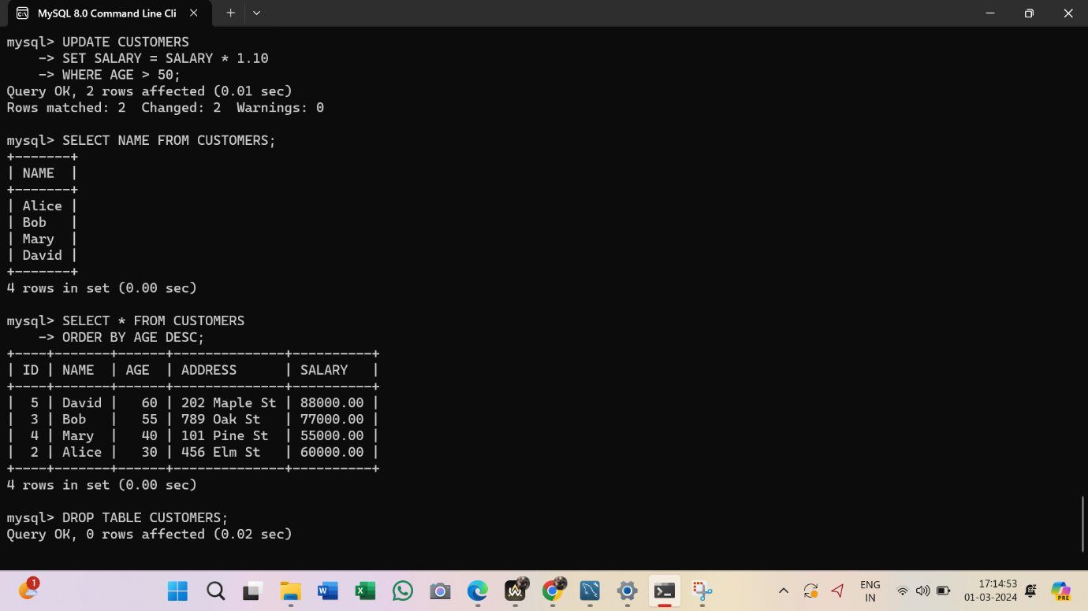

**Q.NO.5. For the following given database, write SQL. Queries: person (driver_id#, name, address) car (license, model, year) accident (reportCno, date, location) owns (driver id#, license) participated (driver_id, car, report_number, damage_amount) (i) Find the total number of people who owned cars that were involved in an accident in 2007. (ii) Find the number of accidents in which the cars belonging to Ajay were involved. (iii) Find the number of accidents that were reported in Mumbai region in the year 2004**

